Thread Management using POSIX Library - Detachment and Cancellation assignments

Mandatory

- Write a program to create 3 threads with the detach and cancel status as below.

Thread# | Detached (Y/N) | Cancel type | Cancel status
1 | Y | PTHREAD_CANCEL_DISABLE
2 | N | PTHREAD_CANCEL_ENABLE | PTHREAD_CANCEL_DEFERRED
3 | N | PTHREAD_CANCEL_ENABLE | PTHREAD_CANCEL_ASYNCHRONOUS

- Let all the threads read and display their detach, cancel type and status and then display thread specific message as below.
T1: Display message in the format as below every 2 secs
<timestamp> Health OK
T2: Print numbers starting from 1000 in steps of 2 at an interval of 3 secs in format as below.
<timestamp> <threadid> <countvalue>

T3: Print numbers starting from 2000 in steps of 2 at an interval of 3 secs
<timestamp> <threadid> < countvalue >
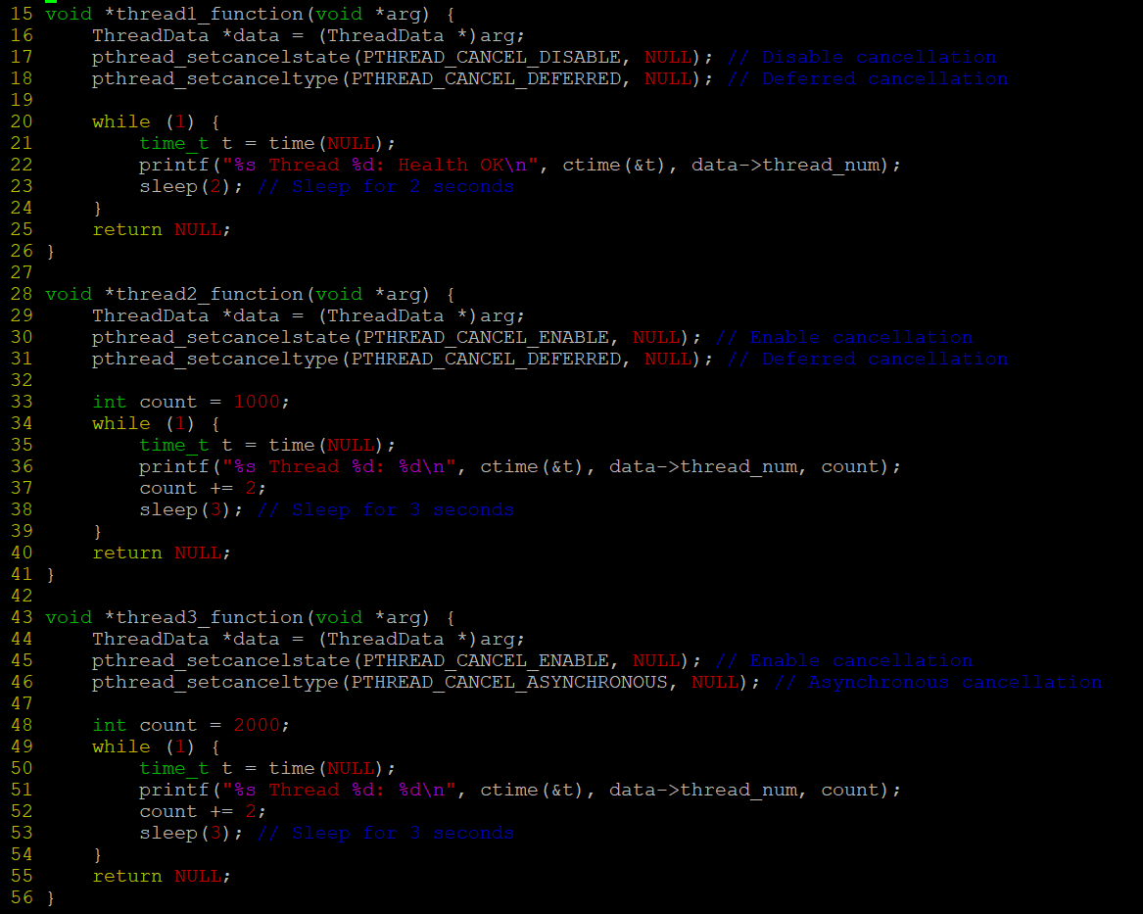

- After creating threads, and after 3 minutes from main(), cancel all 3 threads
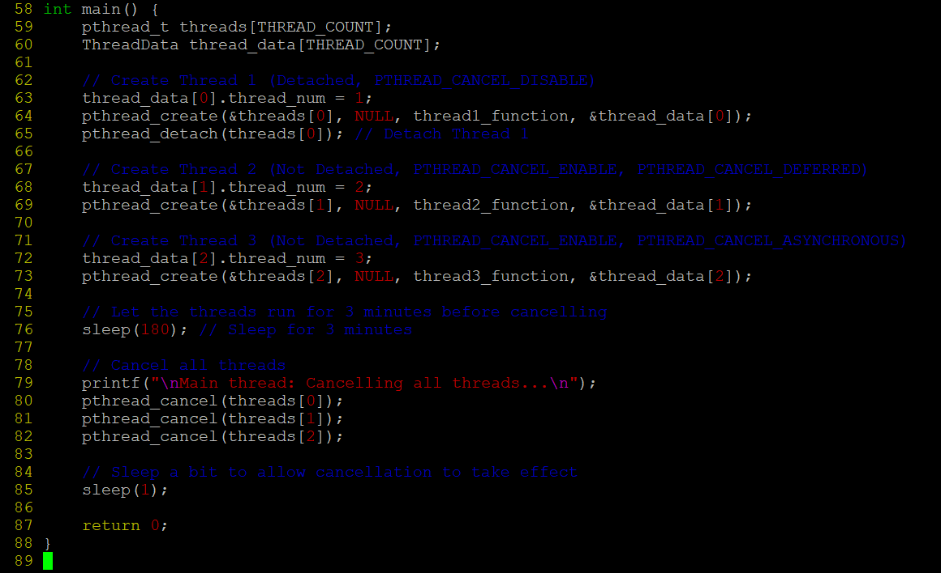
- From an other terminal, use command below to view the thread count of your program
    - ps -eLF
    - top
[For top command usage to refer https://www.golinuxcloud.com/check-threads-per-process-count-processes/ ]

- What difference did you observe between top and ps command?

Difference Between ps and top:
- ps -eLF: Shows a list of all threads for the process, including their states.
- top: Displays the number of threads for a specific process in a summary line, typically showing the total number of threads for each process.

- Which column shows the number of threads in ps and in top commands?

Column Showing Number of Threads:
- In ps -eLF, the LWP (Lightweight Process) column shows the thread ID.
- In top, the TH column shows the number of threads.

- Check the last message timestamp from the threads
Last Message Timestamp:
- The last message timestamp would depend on when the thread is canceled, and you would observe a timestamp just before or after the cancellation in the output
- Which thread was cancelled first and why?

- Thread 1 (PTHREAD_CANCEL_DISABLE) would not respond to cancellation due to the cancellation state being disabled.

- Threads 2 and 3 (PTHREAD_CANCEL_ENABLE) would be canceled, but thread 2 might be canceled first due to its PTHREAD_CANCEL_DEFERRED state, meaning it only responds to cancellation when it reaches a cancellation point (e.g., sleep() or pthread_testcancel()).

- Were all 3 threads cancelled? Justify the observation

- Thread 1 will not be canceled due to PTHREAD_CANCEL_DISABLE. The other two threads (2 and 3) should be canceled, with Thread 2 canceled more likely before Thread 3, due to the difference in cancellation type (PTHREAD_CANCEL_DEFERRED vs. PTHREAD_CANCEL_ASYNCHRONOUS).

